**UJIAN TENGAH SEMESTER PEMROGRAMAN WEB**

**“Program Berbasis Web Untuk Invetarisasi Stok di Barokah Minimarket”**



**DOSEN PENGAMPU**

Fawwaz Ali Akbar, S.Kom., M.Kom

NIP. 199203172018031002

**PEMROGRAMAN WEB A**

Emillia Eka Firnanda

NPM. 18081010026

**PROGRAM STUDI TEKNIK INFORMATIKA**

**FAKULTAS ILMU KOMPUTER**

**UNIVERSITAS PEMBANGUNAN NASIONAL “VETERAN”**

**JAWA TIMUR**

**2020**

**KODE PROGRAM (LINK GITHUB) :**

[**https://github.com/EmilliaEkaFirnanda/Pemrograman-Web-A**](https://github.com/EmilliaEkaFirnanda/Pemrograman-Web-A)

**function.php**

|  |
| --- |
| <?php    $conn = mysqli_connect("localhost","root","", "tokobarokah");  function query ($query){  global $conn;  $result = mysqli_query($conn, $query);  $record = [];  while( $data = mysqli_fetch_assoc($result)){  $record[] = $data;  }  return $record;  }    function input($data){  global $conn;  $id = htmlspecialchars($data["id"]);  $nama_barang = htmlspecialchars($data["nama_barang"]);  $kategori = htmlspecialchars($data["kategori"]);  $jumlah_stok = htmlspecialchars($data["jumlah_stok"]);  $harga_satuan = htmlspecialchars($data["harga_satuan"]);  $query = "INSERT INTO barang VALUES('$id','$nama_barang','$kategori',$jumlah_stok, $harga_satuan) ";  mysqli_query($conn, $query);  return mysqli_affected_rows($conn);  }  function delete($id){  global $conn;  mysqli_query($conn, "DELETE FROM barang WHERE id = '$id' ");  return mysqli_affected_rows($conn);  }    function update($data){  global $conn;  $id = $data["id"];  $nama_barang = htmlspecialchars($data["nama_barang"]);  $kategori = htmlspecialchars($data["kategori"]);  $jumlah_stok = htmlspecialchars($data["jumlah_stok"]);  $harga_satuan = htmlspecialchars($data["harga_satuan"]);  $query = "UPDATE barang SET  id = '$id',  nama_barang = '$nama_barang' ,  kategori = '$kategori',  jumlah_stok = $jumlah_stok ,  harga_satuan = $harga_satuan  WHERE id = '$id' ";  mysqli_query($conn, $query);  echo mysqli_error($conn);  echo mysqli_affected_rows($conn);  return mysqli_affected_rows($conn);  }  function search($keyword) {  $query = "SELECT * FROM barang WHERE nama_barang LIKE '%$keyword%' OR id LIKE '%$keyword%' OR kategori LIKE '%$keyword%'";  return query($query);  }  function filter($data){  $min = $data["harga_min"];  $max = $data["harga_max"];  $query = "SELECT barang.id, barang.nama_barang, barang.kategori, barang.jumlah_stok, barang.harga_satuan FROM barang WHERE barang.harga_satuan BETWEEN $min AND $max;";  return query($query);  }  ?> |

**index.php**

|  |
| --- |
| <?php  require "function.php";  global $conn;  $barang = query("SELECT * FROM barang ORDER BY id DESC;");  if (isset($_POST["search"])) {  $barang = search($_POST["keyword"]);  }  if (isset($_POST["filter"])) {  $barang = filter($_POST);  }  ?>  <!DOCTYPE html>  <html>  <head>  <title>UTS</title>  <link rel="stylesheet" href="style.css">  </head>  <body>  <div class="main" align="center">  <br><br>  <h1> BAROKAH MINI-MARKET </h1>  <br>  <a href="input.php">Input Data Barang</a>  <br><br>  <form action="" method="post">  <table border="0px">  <tr>  <td>  <input type="text" name="keyword" size="35" autofocus placeholder="cari (sku/nama/kategori) barang..">  <button type="submit" name="search"> SEARCH </button>  </td>  </tr>  </table>  </form>  <br>  <form action="" method="post">  <table border="0px">  <tr>  <td>  <label for="harga_min">Dari Harga : Rp</label>  <input type="number" name="harga_min" id="harga_min">  </td>  <td>  <label for="harga_max">Sampai Harga : Rp</label>  <input type="number" name="harga_max" id="harga_max">  </td>  <td>  <button type="submit" name="filter"> FILTER</button>  </td>  </tr>  </table>  </form>  <br>  <table border="1px" cellpadding="6px">  <tr>  <th>NO</th>  <th>SKU BARANG</th>  <th>NAMA BARANG</th>  <th>KATEGORI</th>  <th>JUMLAH STOK</th>  <th>HARGA SATUAN (Rp)</th>  <th>PILIH</th>  </tr>  <?php $i=1; foreach ($barang as $brg): ?>  <tr>  <td align="center"><?= $i ?></td>  <td><?= $brg["id"]; ?></td>  <td><?= $brg["nama_barang"]; ?></td>  <td><?= $brg["kategori"]; ?></td>  <td><?= $brg["jumlah_stok"]; ?></td>  <td><?= $brg["harga_satuan"]; ?></td>  <td>  <a href="update.php?id=<?= $brg["id"]; ?>">Update</a> |  <a href="delete.php?id=<?= $brg["id"]; ?>" onclick="return confirm('yakin?');">Delete</a>  </td>  </tr>  <?php $i++; endforeach ?>  </table>  <br><br>  </div>  </body>  </html> |

**input.php**

|  |
| --- |
| <?php  require "function.php";  $conn = mysqli_connect("localhost","root","","tokobarokah");    //cek apakah tombol submit sudah ditekan ato blm  if ( isset($_POST["submit"])) {  if( input($_POST) > 0 ){  echo "  <script>  alert('data berhasil ditambahkan');  document.location.href = 'index.php';  </script>  ";  } else {  echo "  <script>  alert('data gagal ditambahkan');  document.location.href = 'index.php';  </script>  ";  }  }  ?>  <!DOCTYPE html>  <html>  <head>  <title> Input Barang </title>  <link rel="stylesheet" href="style.css">  </head>  <body>  <div class="input" align="center">  <br><br>  <h1>Input Data Barang</h1>  <form action="" method="post">  <table border="0px" cellspacing="0px" cellpadding="5px">  <tr>  <td>  <label for="id">SKU BARANG </label>  <td align="center">:</td>  <td><input type="text" name="id" id="id" required></td>  </td>  </tr>  <tr>  <td>  <label for="nama_barang">NAMA BARANG </label>  <td align="center">:</td>  <td><input type="text" name="nama_barang" id="nama_barang" required></td>  </td>  </tr>  <tr>  <td>  <label for="kategori">KATEGORI </label>  <td align="center">:</td>  <td><input list="kategori" name="kategori" required></td>  <datalist id="kategori">  <option> Makanan </option>  <option> Minuman </option>  <option> ATK </option>  <option> Lainnya </option>  </datalist>  </td>  </tr>  <tr>  <td>  <label for="jumlah_stok">JUMLAH STOK </label>  <td align="center">:</td>  <td><input type="text" name="jumlah_stok" id="jumlah_stok" required></td>  </td>  </tr>  <tr>  <td>  <label for="harga_satuan">HARGA SATUAN (RP) </label>  <td align="center">:</td>  <td><input type="text" name="harga_satuan" id="harga_satuan" required></td>  </td>  </tr>  <tr>  <td>  <br>  <button type="submit" name="submit" align="center">INPUT DATA</button>  </td>  </tr>  </table>  </form>  <br><br>  </div>  </body>  </html> |

**update.php**

|  |
| --- |
| <?php  require "function.php";  $id = $_GET["id"];  $brg = query("SELECT * FROM barang WHERE id = '$id' ")[0];  $conn = mysqli_connect("localhost","root","","tokobarokah");    if ( isset($_POST["submit"])) {  if( update($_POST) > 0 ){  echo "  <script>  alert('data berhasil diubah');  document.location.href = 'index.php';  </script>  ";  } else {  echo mysqli_error($conn);  echo "  <script>  alert('data gagal diubah');  document.location.href = 'index.php';  </script>  ";  }  }  ?>  <!DOCTYPE html>  <html>  <head>  <title> Update Data Barang </title>  <link rel="stylesheet" href="style.css">  </head>  <body>  <div class="update" align="center">  <br>  <h1>Update Data Barang</h1>  <form action="" method="post">  <input type="hidden" name="id" value="<?= $brg["id"]; ?>">  <table border="0px" cellpadding="3px">  <tr>  <td>  <label for="id">SKU BARANG </label>  <td align="center">:</td>  <td><input type="text" name="id" id="id" required value="<?= $brg["id"]; ?>"></td>  </td>  </tr>  <tr>  <td>  <label for="nama_barang">NAMA BARANG </label>  <td align="center">:</td>  <td><input type="text" name="nama_barang" id="nama_barang" required value="<?= $brg["nama_barang"]; ?>"></td>  </td>  </tr>  <tr>  <td>  <label for="kategori">KATEGORI </label>  <td align="center">:</td>  <td><input type="text" name="kategori" id="kategori" required value="<?= $brg["kategori"]; ?>"></td>  </td>  </tr>  <tr>  <td>  <label for="jumlah_stok">JUMLAH STOK </label>  <td align="center">:</td>  <td><input type="text" name="jumlah_stok" id="jumlah_stok" required value="<?= $brg["jumlah_stok"]; ?>"></td>  </td>  </tr>  <tr>  <td>  <label for="harga_satuan">HARGA SATUAN (RP) </label>  <td align="center">:</td>  <td><input type="text" name="harga_satuan" id="harga_satuan" required value="<?= $brg["harga_satuan"]; ?>"></td>  </td>  </tr>  <tr>  <td>  <br>  <button type="submit" name="submit">UPDATE DATA</button>  </td>  </tr>  </table>  </form>  <br><br>  </div>  </body>  </html> |

**delete.php**

|  |
| --- |
| <?php    require "function.php";  $id = $_GET["id"];  if( delete($id) > 0 ) {  echo "  <script>  alert('data berhasil dihapus');  document.location.href = 'index.php';  </script>  ";  } else {  echo "  <script>  alert('data gagal dihapus');  document.location.href = 'index.php';  </script>  ";  }  ?> |

**style.css**

|  |
| --- |
| body{  background: grey;  font-family: arial,lato;  }  .main{  background-color: lightblue;  width: 860px;  margin: auto;  padding-right: 5px;  padding-left: 5px;  border-radius: 20px;  }  .input{  background-color: lightgreen;  width: 840px;  margin: auto;  border-radius: 30px;  }  .update{  background-color: salmon;  width: 840px;  margin: auto;  padding-top: 10px;  padding-bottom: 10px;  border-radius: 30px;  } |

**TAMPILAN WEB :**

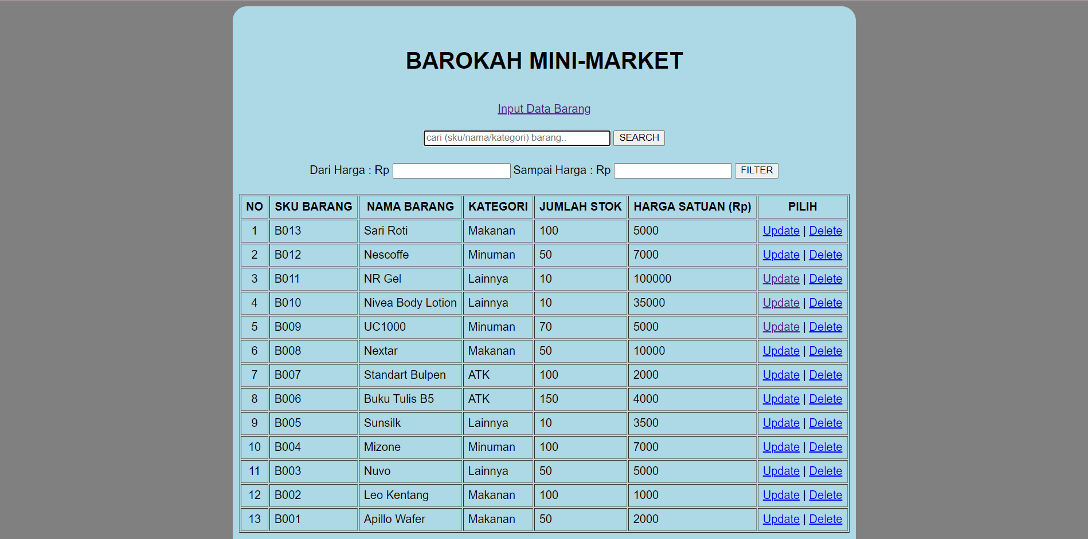

Gambar 1 – *Home Read Database* Data Barang



Gambar 2 – *Input* Data Barang



Gambar 3 – *Update* Data Barang



Gambar 4 – Sebelum *Input* Barang SKU B014

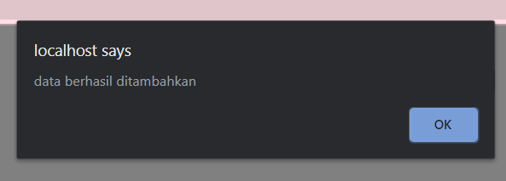

Gambar 5 – Pemberitahuan Data Berhasil di-*input*



Gambar 6 – Setelah *Input* Barang SKU B014



Gambar 7 – Data barang B001 Sebelum di-*update* harga satuan 2000

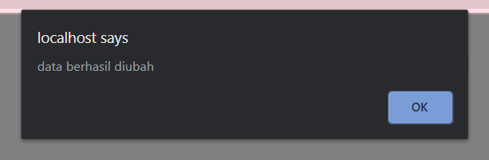

Gambar 8 – Pemberitahuan Data Berhasil di-*update*



Gambar 9 – Data barang B001 setelah di-*update* harga satuan 3500



Gambar 10 – Data barang B008 sebelum di-*delete*

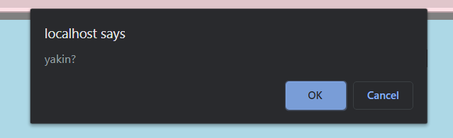

Gambar 11 – Konfirmasi *Delete* data barang

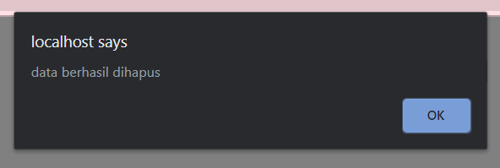

Gambar 12 – Pemberitahuan data berhasil dihapus



Gambar 13 – Data Barang B008 sudah hilang karena berhasil di-*delete*



Gambar 14 – *Form Search*

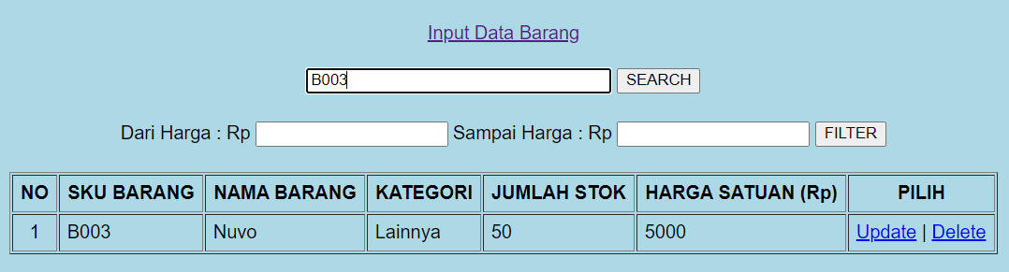

Gambar 15 – Search data barang melalui SKU (B003)

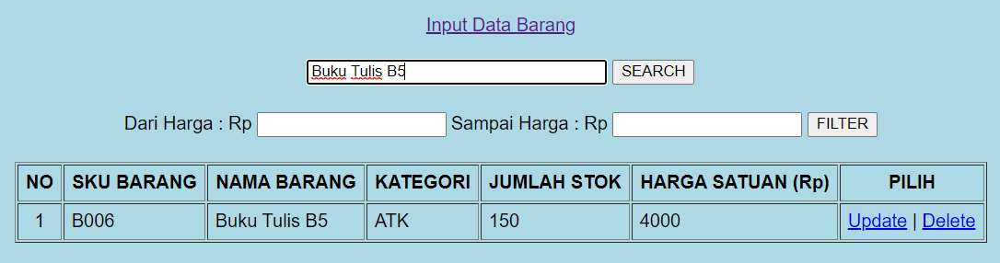

Gambar 16 – Search data barang melalui Nama_Barang (Buku Tulis B5)

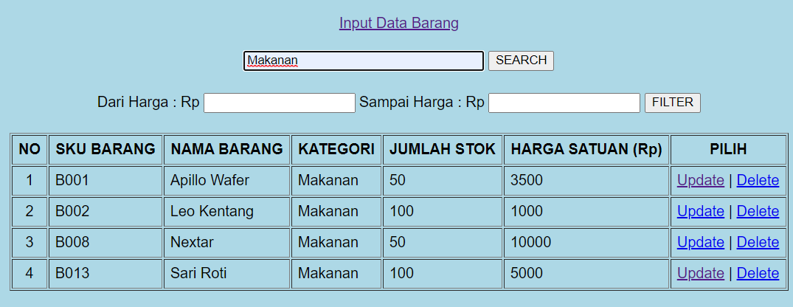

Gambar 17 – Search data barang melalui Kategori (Makanan)



Gambar 18 – *Form* Filter Range Harga

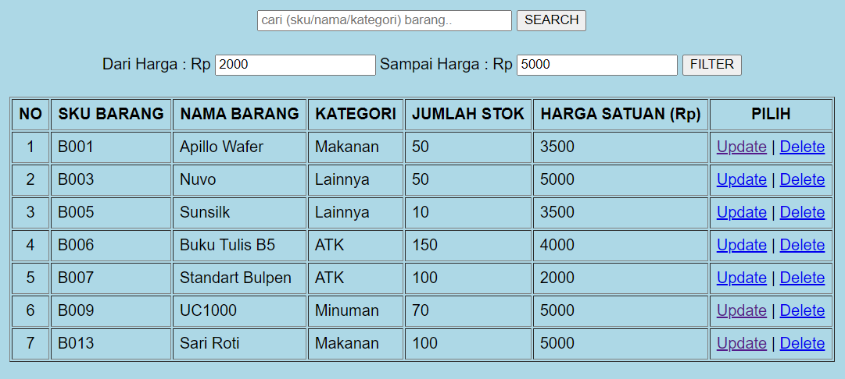

Gambar 19 – Filter Range Harga (2000-5000)

**DATABASE MYSQL PADA XAMPP :**



Gambar 20 – Tabel Barang pada database tokobarokah

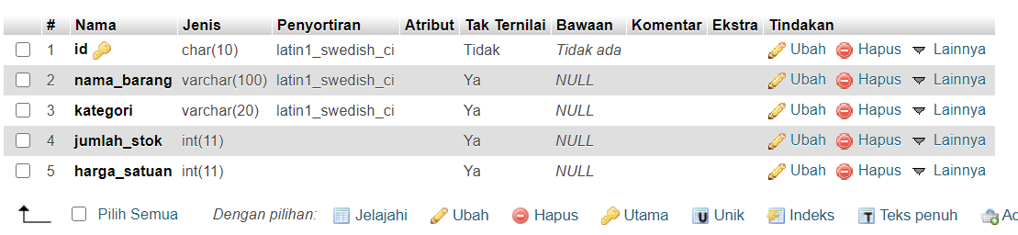

Gambar 21 – Struktur Tabel Barang

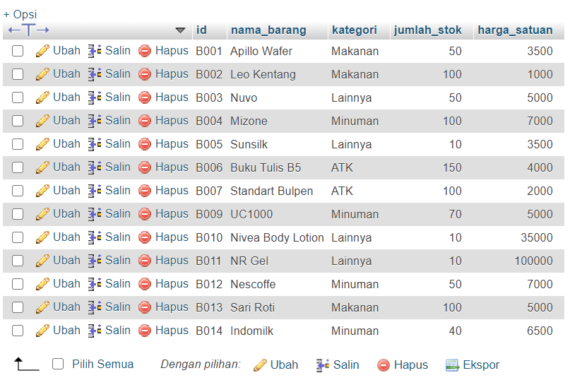

Gambar 22 – Isi Tabel Barang

**FUNGSI UNTUK MENGKONEKSIKAN MYSQL DATABASE DENGAN FILE PHP :**

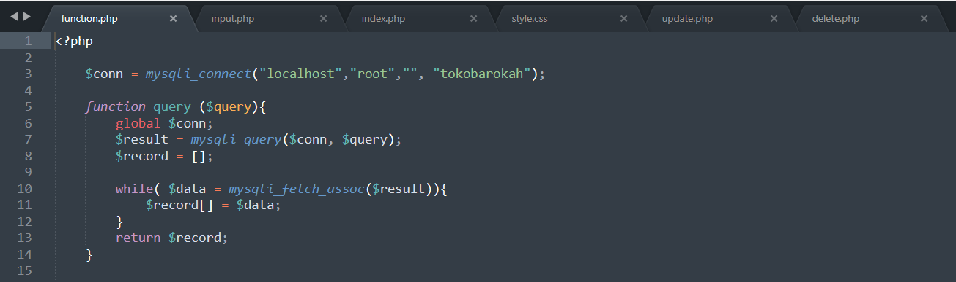

Gambar 23 – *Function read mysql in php*

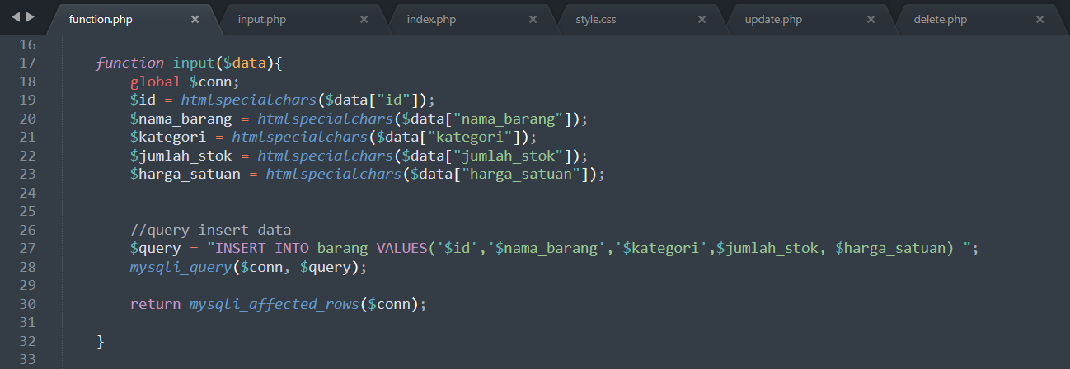

Gambar 24 – *Function input mysql in php*

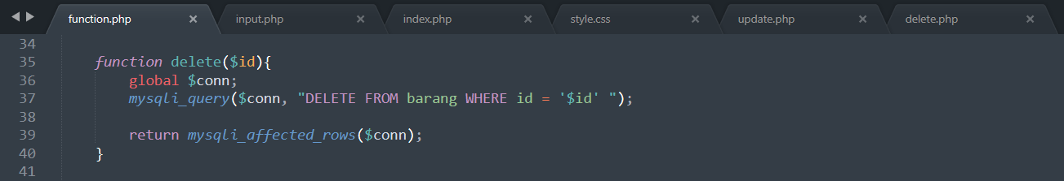

Gambar 25 – *Function delete mysql in php*

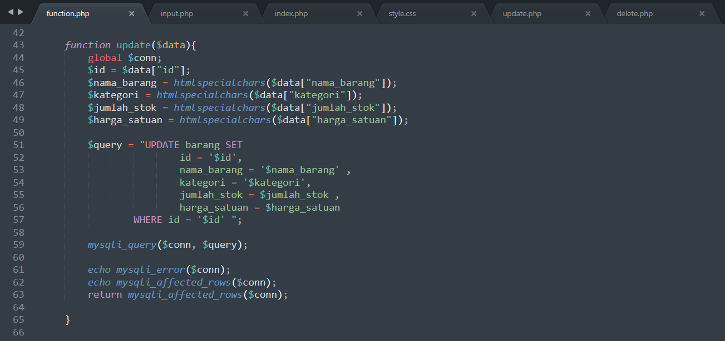

Gambar 26 – *Function update mysql in php*

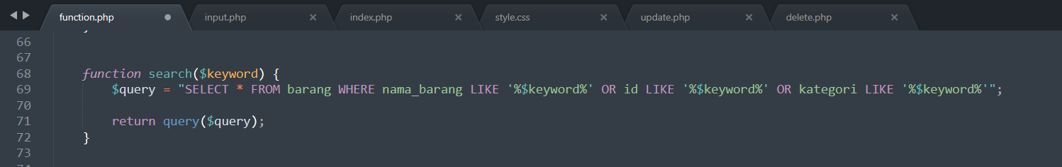

Gambar 27 – *Function search mysql in php*

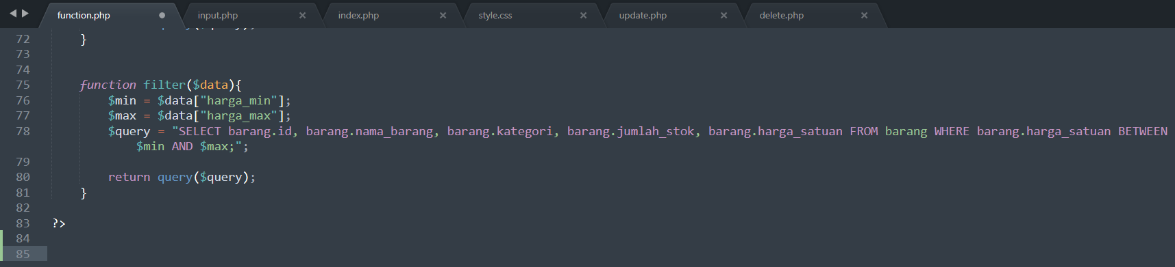

Gambar 28 – *Function sort mysql in php*